Chinese Baptist Church of NW Suburbs
芝城西北郊華人浸信會

4242 Kirchoff Rd, Rolling Meadows IL 60008 847.934.4223
Rev Benjamin Tam 譚人元牧師 http://www.cbcnws.org

2013 Theme 二零一三年度主題
Love the Lost: Luke 15 愛那失喪的: 路加福音十五章

Offering and Attendance 奉獻及出席崇拜人數
Date  日期 | Offering 奉獻 |  |  | Worship Attendance 出席人數
Date  日期 | General  常費 | Building  建堂 | Cambodia Mission  宣教-柬埔寨 | English  英文 | Chinese  中文 | Combined  聯合 | Visitors  來賓
3/3 | $906.00 | - | $200.00 | 29 | 44 | - | -
3/10 | $5,340.00 | - | - | 27 | 41 | - | -
3/17 | $4,483.00 | - | - | 33 | 48 | - | 2
3/24 | $1,460.00 | - | - | 26 | 35 | - | -

Sunday Worship Worker List 星期日崇拜事奉人員
3/31/2013 | Easter Combined Worship 復活節聯合崇拜
Speaker 講員 | Rev Tam
Translation翻譯 | Ken Chew, Irene Liem
Worship Leader 主席 | Praise Team
Communion Ushers主餐司事 | David Wong, Ed Moy, Edmond Shum, Ken Chew
Ushers 司事 | Jason Peng, Enid Yeung
Recording/Projection 錄音/投射 | Gary Mui, Jonathan Chan
Lunch Crew 午飯清潔 | Gary Mui, Julie Mui, Harri Leung
4/7/2013 | English Worship 英文崇拜  Rev Tam  -  Dorothy Chan | Chinese Worship 中文祟拜
Speaker 講員 | Rev Tam | Rev Tam
Translation 翻譯 | - | Julie Mui
Worship Leader 主席 | Anna Tam, Linda Tam | Wing Chan, Irene Liem
Instrumentalists 樂器司 | Francis Chiu | Edmond Shum
Usher 司事 | Zach Moy, Min Lee | Chi Chan, Ken Chew
Recording/Projection錄音/投射 | Joseph Tam | Andy Moy, Bessie Chau
Lunch Crew 午飯清潔 | Jason Peng, Joseph Tam, Sarah Lau
Welcome to our Easter worship service!
歡迎您參加本教會的復活節主日崇拜!
I am the resurrection and the life. The one who believes in Me will live, even though they die; And whoever lives by believing in Me will never die.
復活在我, 生命也在我。信我的人雖然死了, 也必復活, 凡活著信我的人必永遠不死。
約翰福音 John 11: 25-26

March 31, 2013 |  |  |  | 二零一三年三月三十一日
Prelude 序樂 |  |  |  |  |  |  |  |  |  | Pianist 司琴
Call to Worship prayer宣召祟拜祈禱 |  |  |  |  |  |  |  | Rev Tam 譚人元牧師
Congregational Praise 頌讚 |  |  |  |  |  |  |  | Congregation 會眾
Prayer 祈禱 |  |  |  |  |  |  |  | Worship Leader主席
Offering 奉獻 |  |  |  |  |  |  |  |  | Ushers 司事
Special Presentation  特別詩歌 |  | 重演這生 Live a new life  愛是不保留 Unreserved Love |  |  |  |  |  |  | Worship Team  敬拜小組
Scripture Reading  讀經 | Matthew馬太福音28:1-8  (中文聖經第1503頁) |  |  |  |  |  |  |  |  |  | Worship Leader  主席
Teaching  講道 | The Joy of Easter  復活節的喜樂 |  |  |  |  |  |  |  |  |  | Rev Tam  譚人元牧師
Special Presentation  特別獻奏 | Hymns Medley  聖詩合奏曲 |  |  |  |  |  |  |  |  |  | Pianists  司琴
Communion主餐 |  |  |  |  |  | Rev Tam譚人元牧師
Benediction 祝福 |  |  |  |  |  | Rev Tam 譚人元牧師
Doxology 三一頌 |  |  |  |  |  |  | Congregation 會眾
Announcements 報告 |  |  |  |  |  |  | Rev Tam 譚人元牧師
Postlude 殿樂 |  |  |  |  |  |  | Pianist 司琴

Prayer Items for April 四月祈禱事項

- Pray that God will provide the Chinle church with the right Pastor as they choose between 2 final candidates.
請為Chinle 教會祈禱, 求神為他們預備一位適合的牧師: 現在有兩位候選人。

- Pray for our church ministries. May we glorify God; bring people to come before Christ and magnify God's love. Pray for success in our ministry of the Gospel so that those who are being saved may be added to our number.
請為教會事工禱告, 願各事工都榮耀歸於主; 領人歸主, 擴張主愛。祈求傳福音的事工有果效, 好讓得救的人數增加。

- Pray that God will guard all missionaries that we support and partner with us. Pray that God will provide and supply all their needs.
求神保守我們在世界各地的福音伙伴和傳教士。求神供應他們的需要。

- Pray for the brothers and sisters among us who are undergoing trials and sufferings. May they experience God’s comfort and love; pray that they can “Be still, and know that He is God”.
為我們當中正在受試煉和患難的弟兄姊妹祈禱。祈求他們能經歷神的安慰和慈愛。祈求他們能「安靜，要知道祂是神」。
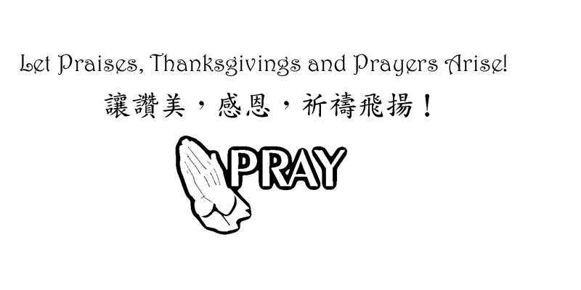
Announcements 家事報告
- Please note the small group meeting this week
請留意這星期的小組活動及聚會:
4/3 | Wed | 8 pm | 英語祈禱會English Prayer Meeting
4/4 | Thurs | 7 pm | 但以理團契Daniel Fellowship

- We need VBS teachers and helpers! Please talk to Irene if you can help.
我們需要暑期聖經班的教師和事奉人員! 如能幫助者, 請與林蘊菁 (Irene) 姊妹接洽。

Church Meetings and small group schedule
教會各聚會及小組活動時間

English Worship  英文崇拜 | Sunday 9:45 am  星期日上午九時四十五分 | Chinese Worship  中文(粵/國)崇拜 | Sunday 11 am  星期日  上午十一時
Combined communion Worship(English/Chinese)  聯合聖餐崇拜 (英/粵/國) | Last Sunday of the month 11am  最後一個星期日上午十一時 | Children Worship  兒童崇拜 | Sunday 9:45 am  星期日上午  九時四十五分
English Sunday School  英文主日學 | Sunday 11 am  星期日  上午十一時 | Chinese Sunday School  中文主日學  (粵/國) | Sunday 9:45 am  星期日上午  九時四十五分
Youth Group (English)  青少年團契 (英) | Every first Saturday 7 pm  每月第一個星期六晚上七時 | English Prayer Meeting  英文祈禱會 | Wednesday 8pm  星期三  晚上八時
Marriage Journey Fellowship (For younger married couples)  年青伉儷團契 | Every second Saturday 7 pm  每月第二個  星期六晚上七時 | Married Adult Fellowship  伉儷團契 | Every third Saturday 6:30pm  每月第三個星期六晚上六時半
Daniel Fellowship (Cantonese group - all ages are welcome)  粵語但以理團契  (任何年齡都歡迎) | First and third Thursday 7 pm  每月第一, 三個  星期四晚上七時 | Women Bible Study Group (Cantonese)  婦女查經班 (粵) | Every other Saturday 9:30am  隔一星期六  早上九時半

