Announcements 家事報告

- Please note the small group meeting this week 請留意這星期的小組活動:
12/4 | Tue | 7:00 pm | 粵語查經班 @ Pastor’s house
12/5 | Wed | 8:00 pm | English Prayer Meeting
12/6 | Thu | 7:00 pm | 但以理團契 @ Pastor’s house

- This year our church Christmas combined worship will be on Sunday, 12/23, at 11 am. Christmas Eve pot-luck dinner will be on 12/24, Monday evening at 5:30 pm. After dinner we will have a short program – we will have a time of worship, special presentation and a skit. Please invite your family and friends to come! Sign-up sheet for potluck is on the table outside.
今年教會的聖誕節聯合崇拜將於12/23 星期日早上十一時舉行。平安夜聚餐將於12/24星期一晚上五時半舉行, 形式是一家一餸晚餐, 聚餐後將有聚會: 敬拜，獻奏，短劇。 請邀請家人和朋友參加! 一家一餸晚餐的報名表在外面的枱。

- Today right after lunch we will decorate our church for Christmas. If you can stay after lunch, please help us out! Thank you!
今天午飯後，我們會開始為教會作聖誕節的佈置。如果您有空的話，請留步幫忙。謝謝大家!

- Julie Mui has provided pictures from 2004, 2006, and 2008. Min has provided videos of the Thanksgiving program. Please see our website for pictures and videos. Continue to give Ed your pictures and videos from years past.
請在網頁參閱Julie提供2004, 2006及2008年的照片. Min提供了感恩節目的錄影片. 如您有往年的照片及錄影片, 請給與Ed.

- Pictures in the Fellowship hall digital picture frame feature Christmas until the end of the year. Thanks to Gary for donating the frame.
照片在交誼廳的數碼相架會陳設至年底. 多謝Gary的奉獻.

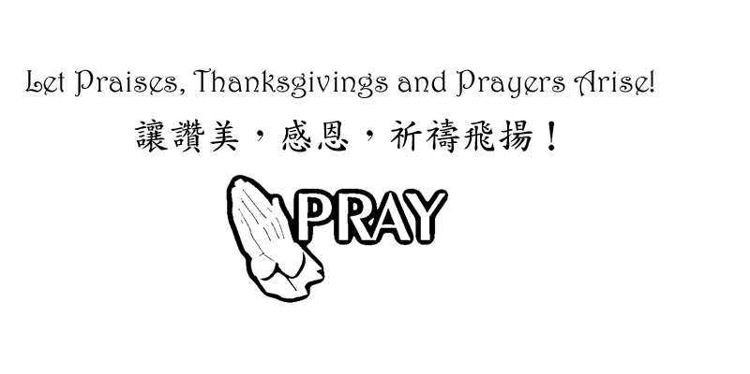

Chinese Baptist Church of NW Suburbs 847.934.4223
芝城西北郊華人浸信會 Rev Benjamin Tam 譚人元牧師
4242 Kirchoff Rd, Rolling Meadows IL 60008 http://www.cbcnws.org

Year of Prayer 禱告年
December 2, 2012 |  |  |  |  | 二零一二年十二月二日
Prelude 序樂 |  |  |  |  |  |  |  |  |  | Pianist 司琴
Call to Worship 宣召祟拜 |  |  |  |  |  |  |  | Worship Leader 主席
Congregational Praise 頌讚 |  |  |  |  |  |  |  | Congregation 會眾
Prayer 祈禱 |  |  |  |  |  |  |  | Worship Leader 主席
Offering 奉獻 |  |  |  |  |  |  |  |  | Ushers  司事
Scripture Reading  讀經 | 1 John 約翰一書2:18-23  (第1853頁) |  |  |  |  |  |  |  |  |  | Worship Leader  主席
Teaching  講道 | Testing Your End Times IQ  測驗末世的認識 |  |  |  |  |  |  |  |  |  | Rev Ben Tam  譚人元牧師
Response Hymn  回應詩歌 | #203 Jesus, Thy Blood and Righteousness  耶穌的寶血和公義 |  |  |  |  |  |  |  |  |  | Congregation  會眾
Benediction 祝福 |  |  |  |  |  | Rev Ben Tam 譚人元牧師
Doxology 三一頌 |  |  |  |  |  |  | Congregation 會眾
Announcements 報告 |  |  |  |  |  |  | Worship Leader 主席
Postlude 殿樂 |  |  |  |  |  |  | Pianist 司琴

Rejoice always, pray continually, give thanks in all circumstances;
For this is God’s will for you in Christ Jesus. 要常常喜樂，不住的禱告，凡事謝恩；因為這是神在基督耶穌裡向你們所定的旨意. 帖撒羅尼迦前書 1 Thessalonians 5: 16-18

Prayer Requests for December 十二月祈禱事項

- Pray for our church year-end programs in Thanksgiving and Christmas. May everything that our church does will glorify God; bring people to come before Christ and magnify God’s love.
為教會年底感恩節和聖誕節的聚會祈禱。願教會的一切聚會和事工能榮神益人; 帶領每一個人就近主耶穌; 和彰顯主愛。

- Pray that we may not be distracted from our focus of worship-service-spiritual growth-evangelism-loving one another. Pray for success in our ministry of the Gospel so that those who are being saved may be added to our number.
祈求我們定睛在崇拜, 事奉, 屬靈長進, 傳福音和彼此相愛上.
祈求傳福音的事工有果效, 好讓得救的人數增加。

- Pray for our partners in the gospel throughout the world: Hurds in Taiwan, Browns in Taiwan, Hegdahls in India, FEBC in broadcasting to China, Go International in SE Asia and South and Central America. Pray that God may guard them against the Evil One and that God may establish the labor of their ministry.
為我們在世界各落的福音伙伴禱告: 在台灣的Hurds及Browns; 在印度的Hegdahls; 遠東廣播在中國的廣播; 在東南亞及中南美的 華傳. 求神保守他們能敵對邪惡和建立他們的事工。

- Pray for the elderlies and infirmed in our congregation. Pray for God's grace and strength on them as well as on their care-givers.
為年長和身體軟弱的禱告.求神賜他們恩典和力量, 也賜力量予照顧他們的。

- Pray for pastor and leaders of our church that we may serve with joy, humility and wisdom of the Lord, honoring, appreciating and encouraging one another.
為牧師及教會領導禱告, 願我們樂於事奉, 謙卑, 和有神的智慧, 互相尊敬, 感謝和勉勵。

Offering and Attendance 奉獻及出席人
Date  日期 | Offering 奉獻 |  |  | Worship Attendance 出席人數
Date  日期 | General  常費 | Building  Cont’cy  建堂 | AZ  Mission  短宣 | English  英文 | Chinese  中文 | Combined  聯合 | Visitors  來賓
11/4 | $4,061.00 | - | - | 22 | 43 | - | 2
11/11 | $4,006.00 | - | - | 26 | 39 | - | 1
11/18 | $1,074.00 | - | - | 26 | 37 | - | -
11/25 | $1,771.51 | - | - | - | - | 74 | 10

Meetings Schedule 聚會時間
English Worship  英文崇拜 | Sunday 9:45 am 星期日上午九時四十五分 | English Prayer Meeting  英文祈禱會 | Wed 8:00 pm  星期三晚上八時
Chinese Worship  中文崇拜 | Sunday 11:00 am  星期日上午十一時 | Marriage Journey  家庭團契 | 2 - Sat 7:00 pm  2星期六晚上七時
Children Worship  兒童崇拜 | Sunday 9:45 am 星期日上午九時四十五分 | Married Adult Fellowship  伉儷團契 | 3-Sat 6:30 pm  3星期六晚上六時半
Chinese Sunday School 中文主日學 | Sunday 9:45 am 星期日上午九時四十五分 | Daniel Fellowship  粵語但以理團契 | 1,3 - Thurs 7 pm  1,3星期四晚上七時
English Sunday School 英文主日學 | Sunday 11:00 am  星期日上午十一時 | Women Bible Study  婦女查經班 | Alt Sat 9:30 am  星期六早上九時半
Youth Group  青少年團契 | Alt Sat 7:00 pm  星期六晚上七時 | Choir Practice  詩班練習 | Sunday 8:00 am  星期日上午八時

Worker List 崇拜事奉人員
12/2/2012 | English Worship 英文崇拜  Rev Tam  -  Dorothy Chan | Chinese Worship 中文祟拜
Speaker 講員 | Rev Tam | Rev Tam
Translation 翻譯 | - | Julie Mui
Worship Leader 主席 | Dorothy Chan | David Wong, Irene Liem
Instrumentalists 樂器司 | Helen Chang | Edmond Shum
Usher 司事 | Monte Chen, Min Lee | Chi Chan, Enid Yueng
Recording/Projection錄音/投射 | Ed Moy/Dorothy Chan | Luke Leung/Bessie Chau
Lunch Crew 午飯清潔 | David Wong, Jonathan Chan, Rebecca Chen
12/9/2012 | English Worship 英文崇拜  Rev Tam  -  Dorothy Chan | Chinese Worship 中文祟拜
Speaker 講員 | Rev Tam | Rev Tam
Translation 翻譯 | - | Irene Liem
Worship Leader 主席 | Ed Moy, Jonathan Chan | Edmond Shum, Wing Chan
Instrumentalists 樂器司 | Lily Hoops | Francis Chiu
Usher 司事 | Jason Peng, Min Lee | Selan Chan, Angela Chan
Recording/Projection錄音/投射 | Joseph Tam/Jonathan Chan | Andy Mou/Bessie Chau
Lunch Crew 午飯清潔 | Linda Tam, Ken Chew, Shawn Tan

