Announcements 家事報告

- Please note the small group meeting this week 本星期的小組聚會如下:
11/28 Wed 8:00 pm English Prayer Meeting 英語祈禱會

- All the photos that Ed has to date have been put on our website. Please see pictures from 2002-2012 (missing some years) at cbcnws.org. Please continue to give Ed any pictures you have so they can be added to our site. 教會2002至2012年的照片現已上載到教會網站（仍欠缺一些年份），大家可到教會網站瀏覽 cbcnws.org。
如果大家還有任何教會活動的相片，請把相片或文件存檔給 Ed。
- The Chicago Chinese Christian Chorale will have an All-City Worship evening on 12/2 at 4 pm. Please see flyers for more information.
芝加哥中國基督徒合唱團將於十二月二日下午4時在 Elk Grove Baptist Church 舉行全城敬拜讚美音樂會，主題為榮耀獨歸我神。
合唱團將以不同風格的聖樂來歌頌耶和華的大能和慈愛，會衆亦將被邀請同唱多首熟悉的聖詩與及彌賽亞神曲中著名的“哈利路亞”來讚美神。免費入場。自由奉獻。
會後大芝加哥教牧同工，合唱團團員於 Royal Buffet (Hoffman Estates) 聚餐和聯誼。歡迎各弟兄姊妹朋友自由參與，費用自付。

- Congratulations to Joseph and Monica Wong for the birth of their grandson, Liam Joseph Hartmann, on 11/19/2012.
熱烈恭喜 Joseph 和 Monica. 他們於11/19 喜獲孫兒 Liam Joseph Hartmann.

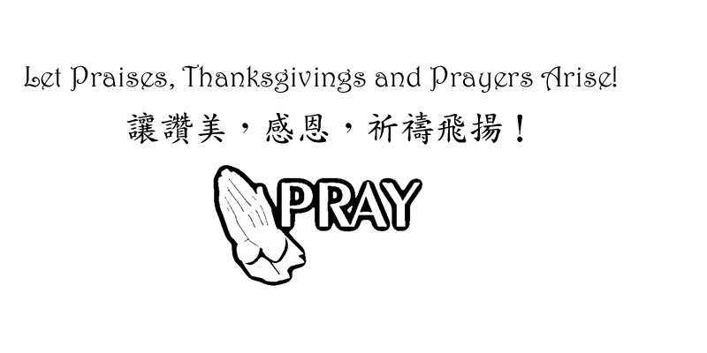

Chinese Baptist Church of NW Suburbs
芝城西北郊華人浸信會

4242 Kirchoff Rd, Rolling Meadows IL 60008 847.934.4223
Rev Benjamin Tam 譚人元牧師 http://www.cbcnws.org

Welcome to our Sunday morning worship!
歡迎您參加本教會的主日崇拜!

Year of Prayer 禱告年

November 25, 2012 二零一二年十一月二十五日

Prelude 序樂 Pianist 司琴
Call to worship 宣召祟拜 Worship Leader 主席
Congregational Praise 頌讚 Congregation 會眾
Prayer 祈禱 Worship Leader 主席
Offering 奉獻 Ushers 司事
Scripture Reading John 16:5, 12-15; 20:21 Congregation
讀經 約翰福音16:5, 12-15; 20:21 (聖經1621頁) 會眾
Teaching 講道 God is a Missionary God 神是個宣教的神 Rev Brown
Response Hymn #478 Pass it on Congregation
回應詩歌 傳給人 會眾
Communion 聖餐 Rev Tam 譚人元牧師
Benediction 祝福 Rev Tam 譚人元牧師
Doxology 三一頌 Congregation 會眾
Announcements 報告 Rev Tam 譚人元牧師
Postlude 殿樂 Pianist 司琴

Jesus said, “Peace be with you! As the Father has sent me, I am sending you.”
耶穌說：願你們平安！父怎樣差遣了我，我也照樣差遣你們。 約翰福音 John 20: 21

Prayer Requests for November 十一月祈禱事項

- Pray for our church year-end programs in Thanksgiving and Christmas. May everything that our church does will glorify God; bring people to come before Christ and magnify God’s love.
為教會年底感恩節和聖誕節的聚會祈禱。願教會的一切聚會和事工能榮神益人; 帶領每一個人就近主耶穌; 和彰顯主愛。

- Pray that we may not be distracted from our focus of worship-service-spiritual growth-evangelism-loving one another. Pray for success in our ministry of the Gospel so that those who are being saved may be added to our number.
祈求我們定睛在崇拜, 事奉, 屬靈長進, 傳福音和彼此相愛上.
祈求傳福音的事工有果效, 好讓得救的人數增加。

- Pray for our partners in the gospel throughout the world: Hurds in Taiwan, Browns in Taiwan, Hegdahls in India, FEBC in broadcasting to China, Go International in SE Asia and South and Central America. Pray that God may guard them against the Evil One and that God may establish the labor of their ministry.
為我們在世界各落的福音伙伴禱告: 在台灣的Hurds及Browns; 在印度的Hegdahls; 遠東廣播在中國的廣播; 在東南亞及中南美的 華傳. 求神保守他們能敵對邪惡和建立他們的事工。

- Pray for the elderlies and infirmed in our congregation. Pray for God's grace and strength on them as well as on their care-givers.
為年長和身體軟弱的禱告.求神賜他們恩典和力量, 也賜力量予照顧他們的。

- Pray for pastor and leaders of our church that we may serve with joy, humility and wisdom of the Lord, honoring, appreciating and encouraging one another.
為牧師及教會領導禱告, 願我們樂於事奉, 謙卑, 和有神的智慧, 互相尊敬, 感謝和勉勵。

Offering and Attendance 奉獻及出席人數
Date  日期 | Offering 奉獻 |  |  | Worship Attendance 出席人數
Date  日期 | General  常費 | Building  Cont’cy  建堂 | AZ  Mission  短宣 | English  英文 | Chinese  中文 | Combined  聯合 | Visitors  來賓
10/28 | $1,093.25 | - | - | - | - | 60 | 1
11/4 | $4,061.00 | - | - | 22 | 43 | - | 2
11/11 | $4,006.00 | - | - | 26 | 39 | - | 1
11/18 | $1,074.00 | - | - | 26 | 37 | - | -

Small group Meetings Schedule 教會小組聚會時間
English Worship  英文崇拜 | Sunday 9:45 am 星期日上午九時四十五分 | English Prayer Meeting 英文祈禱會 | Wed 8:00 pm  星期三晚上八時
Chinese Worship  中文崇拜 | Sunday 11:00 am  星期日上午十一時 | Marriage Journey  家庭團契 | 2nd Sat 7:00 pm  第2星期六晚上七時
Children Worship  兒童崇拜 | Sunday 9:45 am 星期日上午九時四十五分 | Married Adult Fellowship伉儷團契 | 3rd Sat 6:30 pm  第3星期六晚上六時半
Chinese Sunday School 中文主日學 | Sunday 9:45 am 星期日上午九時四十五分 | Daniel Fellowship  粵語但以理團契 | 1st, 3rd - Thurs 7 pm  第1,3星期四晚上七時
English Sunday School 英文主日學 | Sunday 11:00 am  星期日上午十一時 | Women Bible Study  婦女查經班 | Alt Sat 9:30 am  隔一星期六早上九時半
Youth Group  青少年團契 | Alt Sat 7:00 pm  隔一星期六晚上七時 | Choir Practice  詩班練習 | Sunday 8:00 am  星期日上午八時

Worship and Lunch Worker List 崇拜事奉人員
11/25/2012 | Combined Worship 聯合崇拜
Speaker 講員 | Rev Brown
Translation翻譯 | Ken Chew, Brenda Jing
Worship Leader 主席 | Praise Team
Instrumentalist 樂器司 | Praise Team
Ushers 司事 | Monte Chen, Jason Peng
Communion Ushers主餐司事 | David Wong, Ed Moy, Jonathan Chan, Ken Chew
Recording/Projection錄音/投射 | Gary Mui, Jonathan Chan
Lunch Crew 午飯清潔 | Wing Chan, Selan Chan, Joseph Wong
12/2/2012 | English Worship 英文崇拜  Rev Tam  -  Dorothy Chan | Chinese Worship 中文祟拜
Speaker 講員 | Rev Tam | Rev Tam
Translation 翻譯 | - | Julie Mui
Worship Leader 主席 | Dorothy Chan | David Wong, Irene Liem
Instrumentalists 樂器司 | Helen Chang | Edmond Shum
Usher 司事 | Monte Chen, Min Lee | Chi Chan, Enid Yueng
Recording/Projection錄音/投射 | Dorothy Chan, Ed Moy | Bessie Chau, Luke Leung
Lunch Crew 午飯清潔 | David Wong, Jonathan Chan, Rebecca Chen

