Announcements 家事報告

- Please note the small group meeting this week 本星期的小組聚會如下:
11/14 Wed 8:00 pm English Prayer Meeting 英語祈禱會
11/15 Thursday 7:00 pm 但以理團契 Daniel fellowship

- If anyone has any church pictures of any kind from any year – please give the pictures or the files to Ed.
如果大家有任何教會活動及弟兄姊妹的相片，無論是何年何月有何人於相片中，請把相片或文件存檔給 Ed。

- Our church annual Thanksgiving dinner and program will be on 11/24, Saturday:
Potluck dinner at 5:30 pm
Thanksgiving praise and worship night at 7:00pm
Please invite family and friends to come!

教會感恩節聚餐和聚會將於十一月二十四日星期六晚舉行:
晚上五時半: 一家一餸晚餐
晚上七時: 讚美敬拜晚會
請邀請家人和朋友參加!

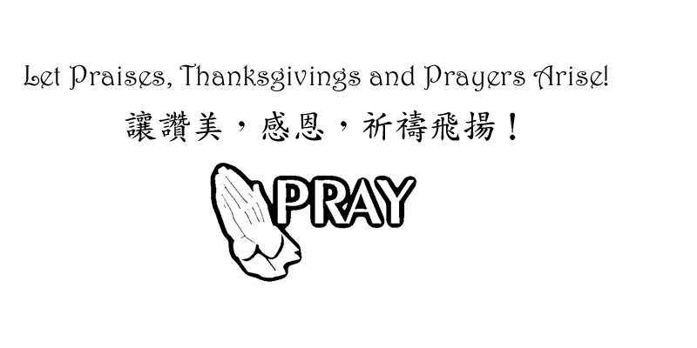

Chinese Baptist Church of NW Suburbs
芝城西北郊華人浸信會

4242 Kirchoff Rd, Rolling Meadows IL 60008 847.934.4223
Rev Benjamin Tam 譚人元牧師 http://www.cbcnws.org

Welcome to our Sunday morning worship!
歡迎您參加本教會的主日崇拜!

Year of Prayer 禱告年

November 11, 2012 二零一二年十一月十一日

Prelude 序樂 Pianist 司琴
Call to worship 宣召祟拜 Worship Leader 主席
Congregational Praise 頌讚 Congregation 會眾
Prayer 祈禱 Worship Leader 主席
Offering 奉獻 Ushers 司事
Scripture Reading 1 John 2:7-11 Congregation
讀經 約翰一書二章7-11節 (聖經1852頁) 會眾
Teaching Hating the wrong target Rev Tam
講道 恨錯對象 譚人元牧師
Response Hymn They will know we are Christians by our love Congregation
回應詩歌 #481 世人知道我們是基督徒是因為愛 會眾
Benediction 祝福 Rev Tam 譚人元牧師
Doxology 三一頌 Congregation 會眾
Announcements 報告 Rev Tam 譚人元牧師
Postlude 殿樂 Pianist 司琴

Rejoice always, pray continually, give thanks in all circumstances;
For this is God’s will for you in Christ Jesus. 要常常喜樂，不住的禱告，凡事謝恩；因為這是神在基督耶穌裡向你們所定的旨意. 帖撒羅尼迦前書 1 Thessalonians 5: 16-18

Prayer Requests for November 十一月祈禱事項

- Pray for our church year-end programs in Thanksgiving and Christmas. May everything that our church does will glorify God; bring people to come before Christ and magnify God’s love.
為教會年底感恩節和聖誕節的聚會祈禱。願教會的一切聚會和事工能榮神益人; 帶領每一個人就近主耶穌; 和彰顯主愛。

- Pray that we may not be distracted from our focus of worship-service-spiritual growth-evangelism-loving one another. Pray for success in our ministry of the Gospel so that those who are being saved may be added to our number.
祈求我們定睛在崇拜, 事奉, 屬靈長進, 傳福音和彼此相愛上.
祈求傳福音的事工有果效, 好讓得救的人數增加。

- Pray for our partners in the gospel throughout the world: Hurds in Taiwan, Browns in Taiwan, Hegdahls in India, FEBC in broadcasting to China, Go International in SE Asia and South and Central America. Pray that God may guard them against the Evil One and that God may establish the labor of their ministry.
為我們在世界各落的福音伙伴禱告: 在台灣的Hurds及Browns; 在印度的Hegdahls; 遠東廣播在中國的廣播; 在東南亞及中南美的 華傳. 求神保守他們能敵對邪惡和建立他們的事工。

- Pray for the elderlies and infirmed in our congregation. Pray for God's grace and strength on them as well as on their care-givers.
為年長和身體軟弱的禱告.求神賜他們恩典和力量, 也賜力量予照顧他們的。

- Pray for pastor and leaders of our church that we may serve with joy, humility and wisdom of the Lord, honoring, appreciating and encouraging one another.
為牧師及教會領導禱告, 願我們樂於事奉, 謙卑, 和有神的智慧, 互相尊敬, 感謝和勉勵。

Offering and Attendance 奉獻及出席人數
Date  日期 | Offering 奉獻 |  |  | Worship Attendance 出席人數
Date  日期 | General  常費 | Building  Cont’cy  建堂 | AZ  Mission  短宣 | English  英文 | Chinese  中文 | Combined  聯合 | Visitors  來賓
10/14 | $226.00 | - | - | 30 | 40 | - | 3
10/21 | $2,730.00 | - | - | 26 | 43 | - | -
10/28 | $1,093.25 | - | - | - | - | 60 | 1
11/4 | $4,061.00 | - | - | 22 | 43 | - | 2

Small group Meetings Schedule 教會小組聚會時間
English Worship  英文崇拜 | Sunday 9:45 am 星期日上午九時四十五分 | English Prayer Meeting 英文祈禱會 | Wed 8:00 pm  星期三晚上八時
Chinese Worship  中文崇拜 | Sunday 11:00 am  星期日上午十一時 | Marriage Journey  家庭團契 | 2nd Sat 7:00 pm  第2星期六晚上七時
Children Worship  兒童崇拜 | Sunday 9:45 am 星期日上午九時四十五分 | Married Adult Fellowship伉儷團契 | 3rd Sat 6:30 pm  第3星期六晚上六時半
Chinese Sunday School 中文主日學 | Sunday 9:45 am 星期日上午九時四十五分 | Daniel Fellowship  粵語但以理團契 | 1st, 3rd - Thurs 7 pm  第1,3星期四晚上七時
English Sunday School 英文主日學 | Sunday 11:00 am  星期日上午十一時 | Women Bible Study  婦女查經班 | Alt Sat 9:30 am  隔一星期六早上九時半
Youth Group  青少年團契 | Alt Sat 7:00 pm  隔一星期六晚上七時 | Choir Practice  詩班練習 | Sunday 8:00 am  星期日上午八時

Worship and Lunch Worker List 崇拜事奉人員
11/11/2012 | English Worship 英文崇拜  Rev Tam  -  Dorothy Chan | Chinese Worship 中文祟拜
Speaker 講員 | Rev Tam | Rev Tam
Translation 翻譯 | - | Irene Liem
Worship Leader 主席 | Anna Tam, Jonathan Chan | Carol Hui, Luke Leung
Instrumentalists 樂器司 | Francis Chiu, Rich Maxwell | Angela Cheong
Usher 司事 | Jason Peng, Min Lee | Selan Chan, Chi Chan
Recording/Projection錄音/投射 | Jonathan Chan, Joseph Tam | Bessie Chau, Andy Moy
Lunch Crew 午飯清潔 | Jason Peng, Angela Chan, Dorothy Chan
11/18/2012 | English Worship 英文崇拜  Rev Tam  -  Dorothy Chan | Chinese Worship 中文祟拜
Speaker 講員 | Rev Tam | Rev Tam
Translation 翻譯 | - | Julie Mui
Worship Leader 主席 | Ed Moy, Jonathan Chan | Edmond Shum, Wing Chan
Instrumentalists 樂器司 | Lily Hoops | Francis Chiu
Usher 司事 | Joseph Tam, Zach Moy | Shawn Tan, Enid Yeung
Recording/Projection錄音/投射 | Jonathan Chan, Gary Mui | Bessie Chau, Andy Moy
Lunch Crew 午飯清潔 | Edmond Shum, Carol Hui, Bessie Chau

