Announcements 家事報告

- Please note the small group meeting this week 本星期的小組聚會如下
10/24 Wed 8:00 pm English Prayer Meeting 英語祈禱會
10/27 Saturday 9:30 am Women Bible Study @ Selan’s house

- Elections for 2013 Church Council / Trustee is coming up soon. The nomination process has begun. Please pray whether God is calling you to serve in one of these positions. Talk to Ed if you have any questions.
2013年同工會/信託選舉提名現已開始,選舉將於十一月舉行。請大家祈禱，尋求神有沒有呼召您在同工會或信託的崗位上事奉。如有問題請與Ed傾談。

- Our dear sister Sophia Shih is moving to California next month. This Saturday (10/27) we will have a farewell luncheon with her. Please let Selan know if you want to join.
Sophia Shih 姊妹將於十一月移居加州。我們在本星期六將會與
她吃午餐，如欲參加請與 Selan 報名。
Time 時間: 10/27, Saturday 1-3 pm.
Place 地點: Hibachi Grill Seafood Buffet in Wheeling

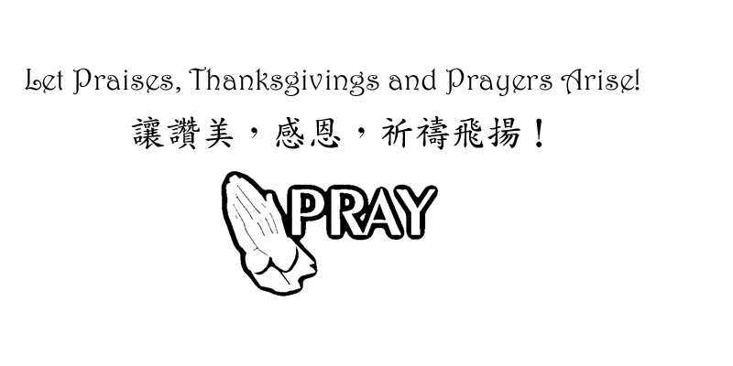

Chinese Baptist Church of NW Suburbs
芝城西北郊華人浸信會

4242 Kirchoff Rd, Rolling Meadows IL 60008 847.934.4223
Rev Benjamin Tam 譚人元牧師 http://www.cbcnws.org

Welcome to our Sunday morning worship!
歡迎您參加本教會的主日崇拜!

Year of Prayer 禱告年

October 21, 2012 二零一二年十月二十一日

Prelude 序樂 Pianist 司琴
Call to worship 宣召祟拜 Worship Leader 主席
Congregational Praise 頌讚 Congregation 會眾
Prayer 祈禱 Worship Leader 主席
Offering 奉獻 Ushers 司事
Scripture Reading 1 John 1:8 – 2:2 Congregation
讀經 約翰一書第一章8節 - 第二章2節 會眾
Teaching Sin’s reality and solutions Rev Tam
講道 罪的現實和解救 譚人元牧師
Response Hymn #74 Grace greater than our sin Congregation
回應詩歌 恩典大過我罪 會眾
Benediction 祝福 Rev Tam 譚人元牧師
Doxology 三一頌 Congregation 會眾
Announcements 報告 Rev Tam 譚人元牧師
Postlude 殿樂 Pianist 司琴

If we confess our sins, He is faithful and just and will forgive us our sins and purify us from all unrighteousness.
我們若認自己的罪，神是信實的，是公義的，必要赦免我們的罪，
洗淨我們一切的不義 約翰一書1 John 1:9

Prayer Requests for October 十月祈禱事項

- Pray that we may not be distracted from our focus of worship-service-spiritual growth-evangelism-loving one another. Pray for success in our ministry of the Gospel so that those who are being saved may be added to our number.
祈求我們定睛在崇拜, 事奉, 屬靈長進, 傳福音和彼此相愛上.
祈求傳福音的事工有果效, 好讓得救的人數增加。

- Pray for our partners in the gospel throughout the world: Hurds in Taiwan, Browns in Taiwan, Hegdahls in India, FEBC in broadcasting to China, Go International in SE Asia and South and Central America. Pray that God may guard them against the Evil One and that God may establish the labor of their ministry.
為我們在世界各落的福音伙伴禱告: 在台灣的Hurds及Browns; 在印度的Hegdahls; 遠東廣播在中國的廣播; 在東南亞及中南美的 華傳. 求神保守他們能敵對邪惡和建立他們的事工。

- Pray for the elderlies and infirmed in our congregation. Pray for God's grace and strength on them as well as on their care-givers.
為年長和身體軟弱的禱告.求神賜他們恩典和力量, 也賜力量予照顧他們的。

- Pray for the sisters who were just baptized. Pray that they will continue to grow in Christ.
為剛受浸加入教會的幾位姊妹禱告, 祈願她們在主裡繼續成長。

- Pray for the pastor and leaders of our church that we may serve with joy, humility and wisdom of the Lord, honoring, appreciating and encouraging one another.
為牧師及教會領導禱告, 願我們樂於事奉, 謙卑, 和有神的智慧, 互相尊敬, 感謝和勉勵。

Offering and Attendance 奉獻及出席人數
Date  日期 | Offering 奉獻 |  |  | Worship Attendance 出席人數
Date  日期 | General  常費 | Building  Cont’cy  建堂 | AZ  Mission  短宣 | English  英文 | Chinese  中文 | Combined  聯合 | Visitors  來賓
9/23 | $1,153.00 | - | - | 25 | 33 | - | -
9/30 | $2,860.00 | $520.00 | - | - | - | 81 | 4
10/7 | $3,140.00 | - | - | 29 | 40 | - | 2
10/14 | $226.00 | - | - | 30 | 40 | - | 3

Small group Meetings Schedule 教會小組聚會時間
English Worship  英文崇拜 | Sunday 9:45 am 星期日上午九時四十五分 | English Prayer Meeting 英文祈禱會 | Wed 8:00 pm  星期三晚上八時
Chinese Worship  中文崇拜 | Sunday 11:00 am  星期日上午十一時 | Marriage Journey  家庭團契 | 2nd Sat 7:00 pm  第2星期六晚上七時
Children Worship  兒童崇拜 | Sunday 9:45 am 星期日上午九時四十五分 | Married Adult Fellowship伉儷團契 | 3rd Sat 6:30 pm  第3星期六晚上六時半
Chinese Sunday School 中文主日學 | Sunday 9:45 am 星期日上午九時四十五分 | Daniel Fellowship  粵語但以理團契 | 1st, 3rd - Thurs 7 pm  第1,3星期四晚上七時
English Sunday School 英文主日學 | Sunday 11:00 am  星期日上午十一時 | Women Bible Study  婦女查經班 | Alt Sat 9:30 am  隔一星期六早上九時半
Youth Group  青少年團契 | Alt Sat 7:00 pm  隔一星期六晚上七時 | Choir Practice  詩班練習 | Sunday 8:00 am  星期日上午八時

Worship and Lunch Worker List 崇拜事奉人員
10/21/2012 | English Worship 英文崇拜  Rev Tam  -  Dorothy Chan | Chinese Worship 中文祟拜
Speaker 講員 | Rev Tam | Rev Tam
Translation 翻譯 | - | Julie Mui
Worship Leader 主席 | Ed Moy, Jonathan Chan | Edmond Shum,  David Wong
Instrumentalists 樂器司 | Lily Hoops | Francis Chiu
Usher 司事 | Monte Chen, Min Lee | Selan Chan, Angela Chan
Recording/Projection 錄音/投射 | Jonathan Chan, Zach Moy | Bessie Chau, Andy Moy
Lunch Crew 午飯清潔 | Gary Mui, Julie Mui, Linda Tam
10/28/2012 | Combined Worship 聯合崇拜
Speaker 講員 | Rev Lau
Translation翻譯 | Dorothy Chan, Brenda Jing
Worship Leader 主席 | Praise Team
Instrumentalist 樂器司 | Praise Team
Ushers 司事 | Shawn Tan, Jason Peng
Communion Ushers主餐司事 | David Wong, Ed Moy, Edmond Shum, Jonathan Chan
Recording/Projection 錄音/投射 | Gary Mui, Jonathan Chan
Lunch Crew 午飯清潔 | Ed Moy, Nai Sum Wong, Harri Leung

