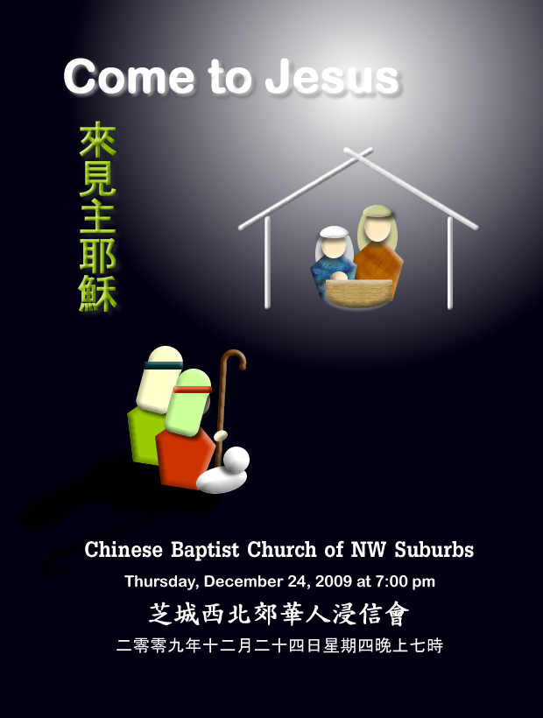

Chinese Baptist Church of Northwest Suburbs
芝城西北郊華人浸信會

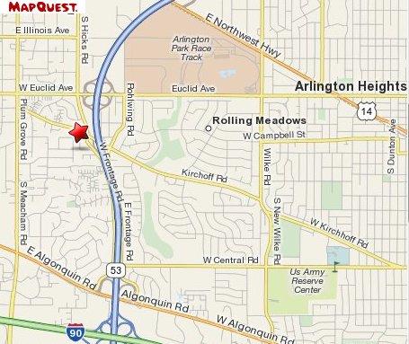

4242 Kirchoff Rd, Rolling Meadows IL 60008
Tel: 847.934.4223 http://www.cbcnws.org

Scripture 經文

Isaiah 9:1-7
¹ Nevertheless, there will be no more gloom for those who were in distress. In the past he humbled the land of Zebulun and the land of Naphtali, but in the future he will honor Galilee of the Gentiles, by the way of the sea, along the Jordan-
² The people walking in darkness have seen a great light; on those living in the land of the shadow of death a light has dawned.
³ You have enlarged the nation and increased their joy; they rejoice before you as people rejoice at the harvest, as men rejoice when dividing the plunder.
⁴ For as in the day of Midian's defeat, you have shattered the yoke that burdens them, the bar across their shoulders, the rod of their oppressor.
⁵ Every warrior's boot used in battle and every garment rolled in blood will be destined for burning, will be fuel for the fire.
⁶ For to us a child is born, to us a son is given, and the government will be on his shoulders. And he will be called Wonderful Counselor, Mighty God, Everlasting Father, Prince of Peace.
⁷ Of the increase of his government and peace there will be no end. He will reign on David's throne and over his kingdom, establishing and upholding it with justice and righteousness from that time on and forever. The zeal of the LORD Almighty will accomplish this.

以賽亞書9:1-7
¹黑暗中之光但那受過困苦的，必不再見幽暗。以前 神使西布倫和拿弗他利地被輕視，日後卻要使它們在沿海之路、約旦河外和外族人的加利利，得著榮耀。
² 行在黑暗中的人民，看見了大光；住在死蔭之地的人，有光照耀他們。
³你使這國之民增多，又加添他們的歡樂；他們在你面前歡樂，好像收割時的歡樂一樣；又像人在均分戰利品時的快樂一般。
⁴ 因為他們所負的軛和肩頭上的杖，以及欺壓他們的人的棍，你都折斷了，像在米甸的日子一樣。
⁵ 因為戰士在戰爭喧嚷中所穿的靴，和輥在血中的袍，都必燒毀，成了燒火的燃料。
⁶ 因為有一個嬰孩為我們而生，有一個兒子賜給我們；政權必擔在他的肩頭上；他的名必稱為“奇妙的策士、全能的 神、永恆的父、和平的君”。
⁷ 他的政權與平安必無窮無盡地增加，他在大衛的寶座上治理他的國，以公平和公義使國堅立穩固，從現在直到永遠。萬軍之耶和華的熱心必成全這事。

Chinese Baptist Church of NW Suburbs 847.934.4223
芝城西北郊華人浸信會 Rev Benjamin Tam 譚人元牧師
4242 Kirchoff Rd, Rolling Meadows IL 60008 http://www.cbcnws.org

December 24, 2009 | 二零零九年十二月二十四日
Prelude
序樂
Congregational Sing
頌讚
“Come and See”  來觀看 |  | Choir  詩班獻詩
“Christ in the University”
基督在大學中
“Special Gifts”  特別的禮物 |  | Children/Teens Sing  兒童/少年獻詩
“Fishing for Treasure”
漁獲至寶
“Jingle Bells”  聖誕鈴聲 |  | Ensemble  合奏
“Make Me A Blessing”
籍我賜恩福
“Angels We Have Heard on High”  請聽天使在高唱 |  | Ensemble  合奏
Games & Gifts
遊戲 &禮物
Candle-lighting
燭光
“Christmas Carol Celebration”  慶祝聖誕頌歌 |  | Choir Anthem & Congregational Sing  頌讚
Postlude/Refreshment
殿樂/茶點

